Project Design Phase-II Technology Stack (Architecture & Stack)

|  |  |
| --- | --- |
| Date | 17 October 2022 |
| Team ID | PNT2022TMID12755 |
| Project Name | Signs With Smart Connectivity for Better Road Safety |
| Maximum Marks | 4 Marks |

# Technical Architecture:

The Deliverable shall include the architectural diagram as below and the information as per the table1 & table 2

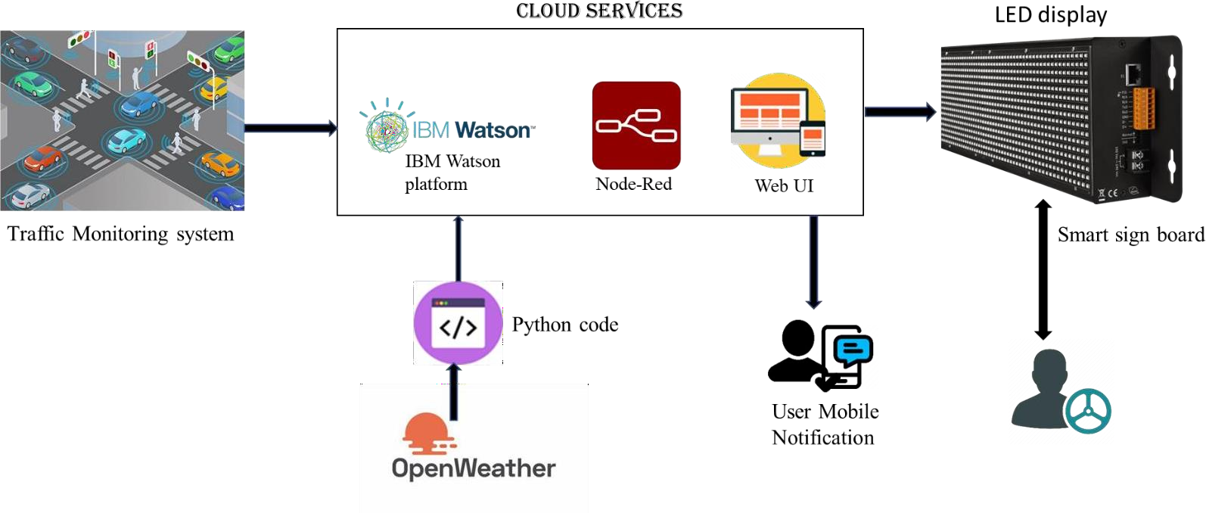

**GUIDELINES:**

* To replace the static signboards, smart connected sign boards are used.
* These smart connected sign boards get the speed limitations from a web app

using weather API and update automatically.

* Based on the weather changes the speed may increase or decrease.
* Based on the traffic and fatal situations the diversion signs are displayed.
* Guide(Schools), Warning and Service(Hospitals, Restaurant) signs are also

displayed accordingly.

* Different modes of operations can be selected with the help of buttons.

# Table-1 : Components & Technologies:

|  |  |  |  |
| --- | --- | --- | --- |
| **S.No** | **Component** | **Description** | **Technology** |
| 1. | User Interface | How user interacts with application e.g.  Web UI, Mobile App, Chatbot etc. | HTML, CSS, JavaScript / Angular Js /  React Js etc. |
| 2. | Application Logic-1 | Logic for a process in the application | Java / Python |
| 3. | Application Logic-2 | Logic for a process in the application | IBM Watson STT service |
| 4. | Application Logic-3 | Logic for a process in the application | IBM Watson Assistant |
| 5. | Database | Data Type, Configurations etc. | MySQL, NoSQL, etc. |

|  |  |  |  |
| --- | --- | --- | --- |
| 6. | Cloud Database | Database Service on Cloud | IBM DB2, IBM Cloudant etc. |
| 7. | File Storage | File storage requirements | IBM Block Storage or Other Storage Service or Local Filesystem |
| 8. | External API-1 | Purpose of External API used in the application | IBM Weather API, etc. |

**Table-2: Application Characteristics:**

|  |  |  |  |  |  |  |  |
| --- | --- | --- | --- | --- | --- | --- | --- |
| **S.** | **Characteristics** | **Description** | | | | **Technology** | |
| **No** |
| 1. | Security | Strong | security | system | that | Firewall, | |
| Implementations | anyone without login credentials | | | | Firebase, | cyber |
|  | and hackers are not allowed to | | | | resiliency | |
|  | enter the network. Establish a range of security controls to protect assets residing on systems and networks. Consider use of access controls at your network, and use of data encryption technologies (VPN too) as required. Use removable storage media for critical data so that it can be physically secured. | | | | strategy | |
| 2. | Scalable | Easy to expand the operating range | | | | IoT, internet. | |
| Architecture | by increasing the bandwidth of the | | | |
|  | network. A scalable architecture is an architecture that can scale up to meet increased work loads. In other words, if the work load all of a sudden exceeds the capacity of your existing software + hardware combination, you can scale up the system (software + hardware) to meet the increased work load. | | | |
| 3. | Availability | Available anytime and everywhere | | | | IBM Cloud | |
| 24/7 as long as the user is signed into | | | |
| the network. | | | |
| 4. | Performance | Supports a large number of users to | | | | IBM cloud | |
| access the technology | | | |
| simultaneously. | | | |